‘’

[Date]

Team LOCALHOST

Agile systems

AR-VR PAAS

[Document subtitle]

**Project Title: AR – VR PaaS**

**Group Name: LOCALHOST**

**Group Members:**

|  |  |  |
| --- | --- | --- |
| **NAME** | **SAP ID** | **ROLL NO.** |
| **Aditya Kumar** | **500066319** | **04** |
| **Anuj Verma** | **500066910** | **09** |
| **Dhananjai Kalra** | **500070904** | **14** |
| **Mayank Joshi** | **500070105** | **25** |

Contents

Introduction 3

Objective and Aim 4

Requirements (as for now) 5

# Introduction

This project is based on latest and emerging technologies like **Augmented Reality and Virtual Reality**. We are developing a **Platform as a Service** for the users who want to create their own Augmented Reality and Virtual Reality content. This platform can also serve as a marketplace for selling and buying the AR and VR content. The users can access the platform on a subscription basis.

We are looking forward to making the process of generating AR and VR content very user friendly. The users can view and modify their AR and VR content in real time while generating it. The users can save their content on their system for a nominal charge (inclusive in the subscription).

The service will fulfill all the needs of the user in generating AR and VR content. The software will run on our servers and an instance of the process will be displayed on the user’s desktop.

The platform will be developed exactly according to the needs of the customers.

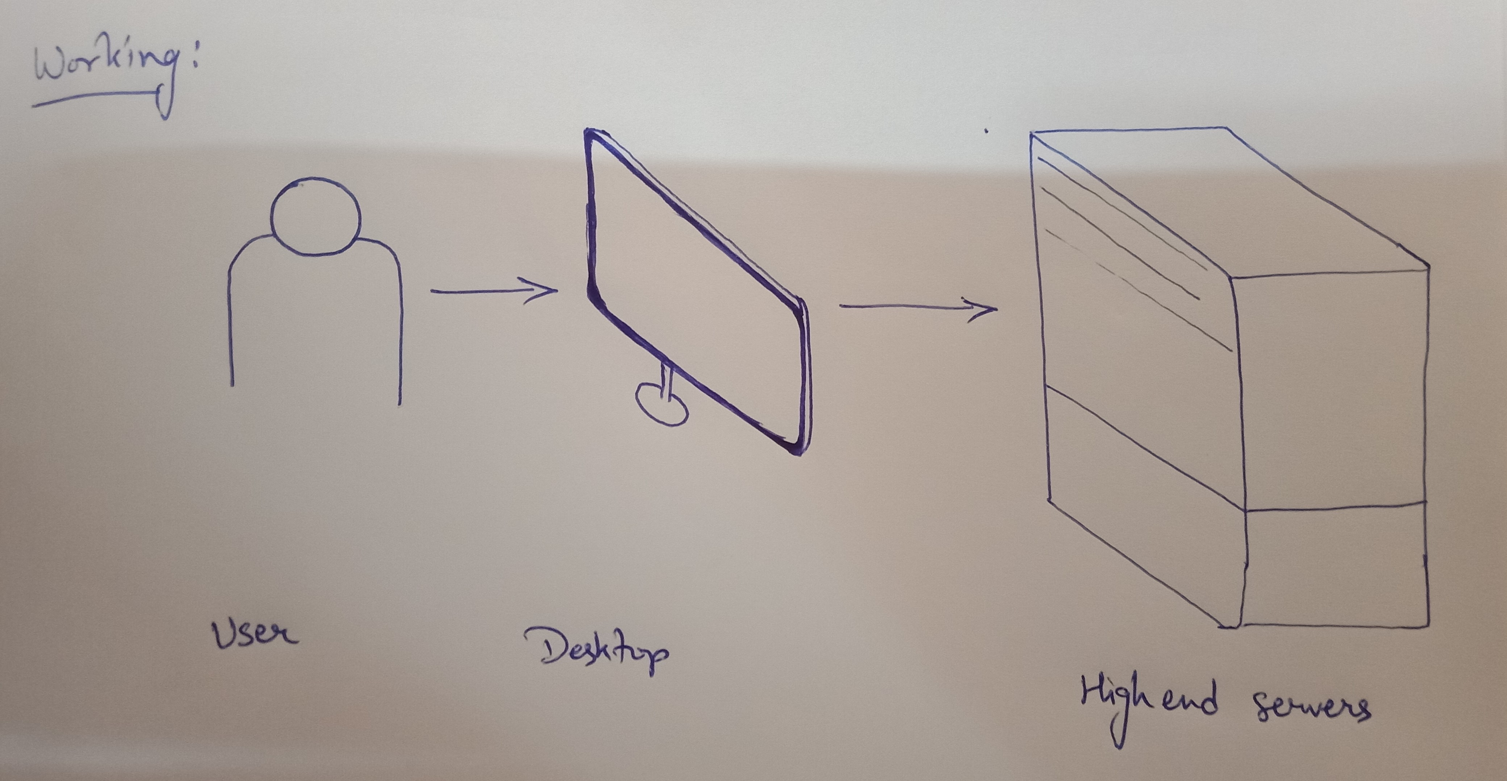

# Objective and Aim

* This platform can provide development of AR and VR content such as videos, photos and applications
* This platform can also work as a marketplace for users to create and sell their AR and VR content
* Provide the service to people who cannot afford high performance hardware (by giving them subscription service to our platform)
* Provide service to institutions and organizations for mass use at low cost.

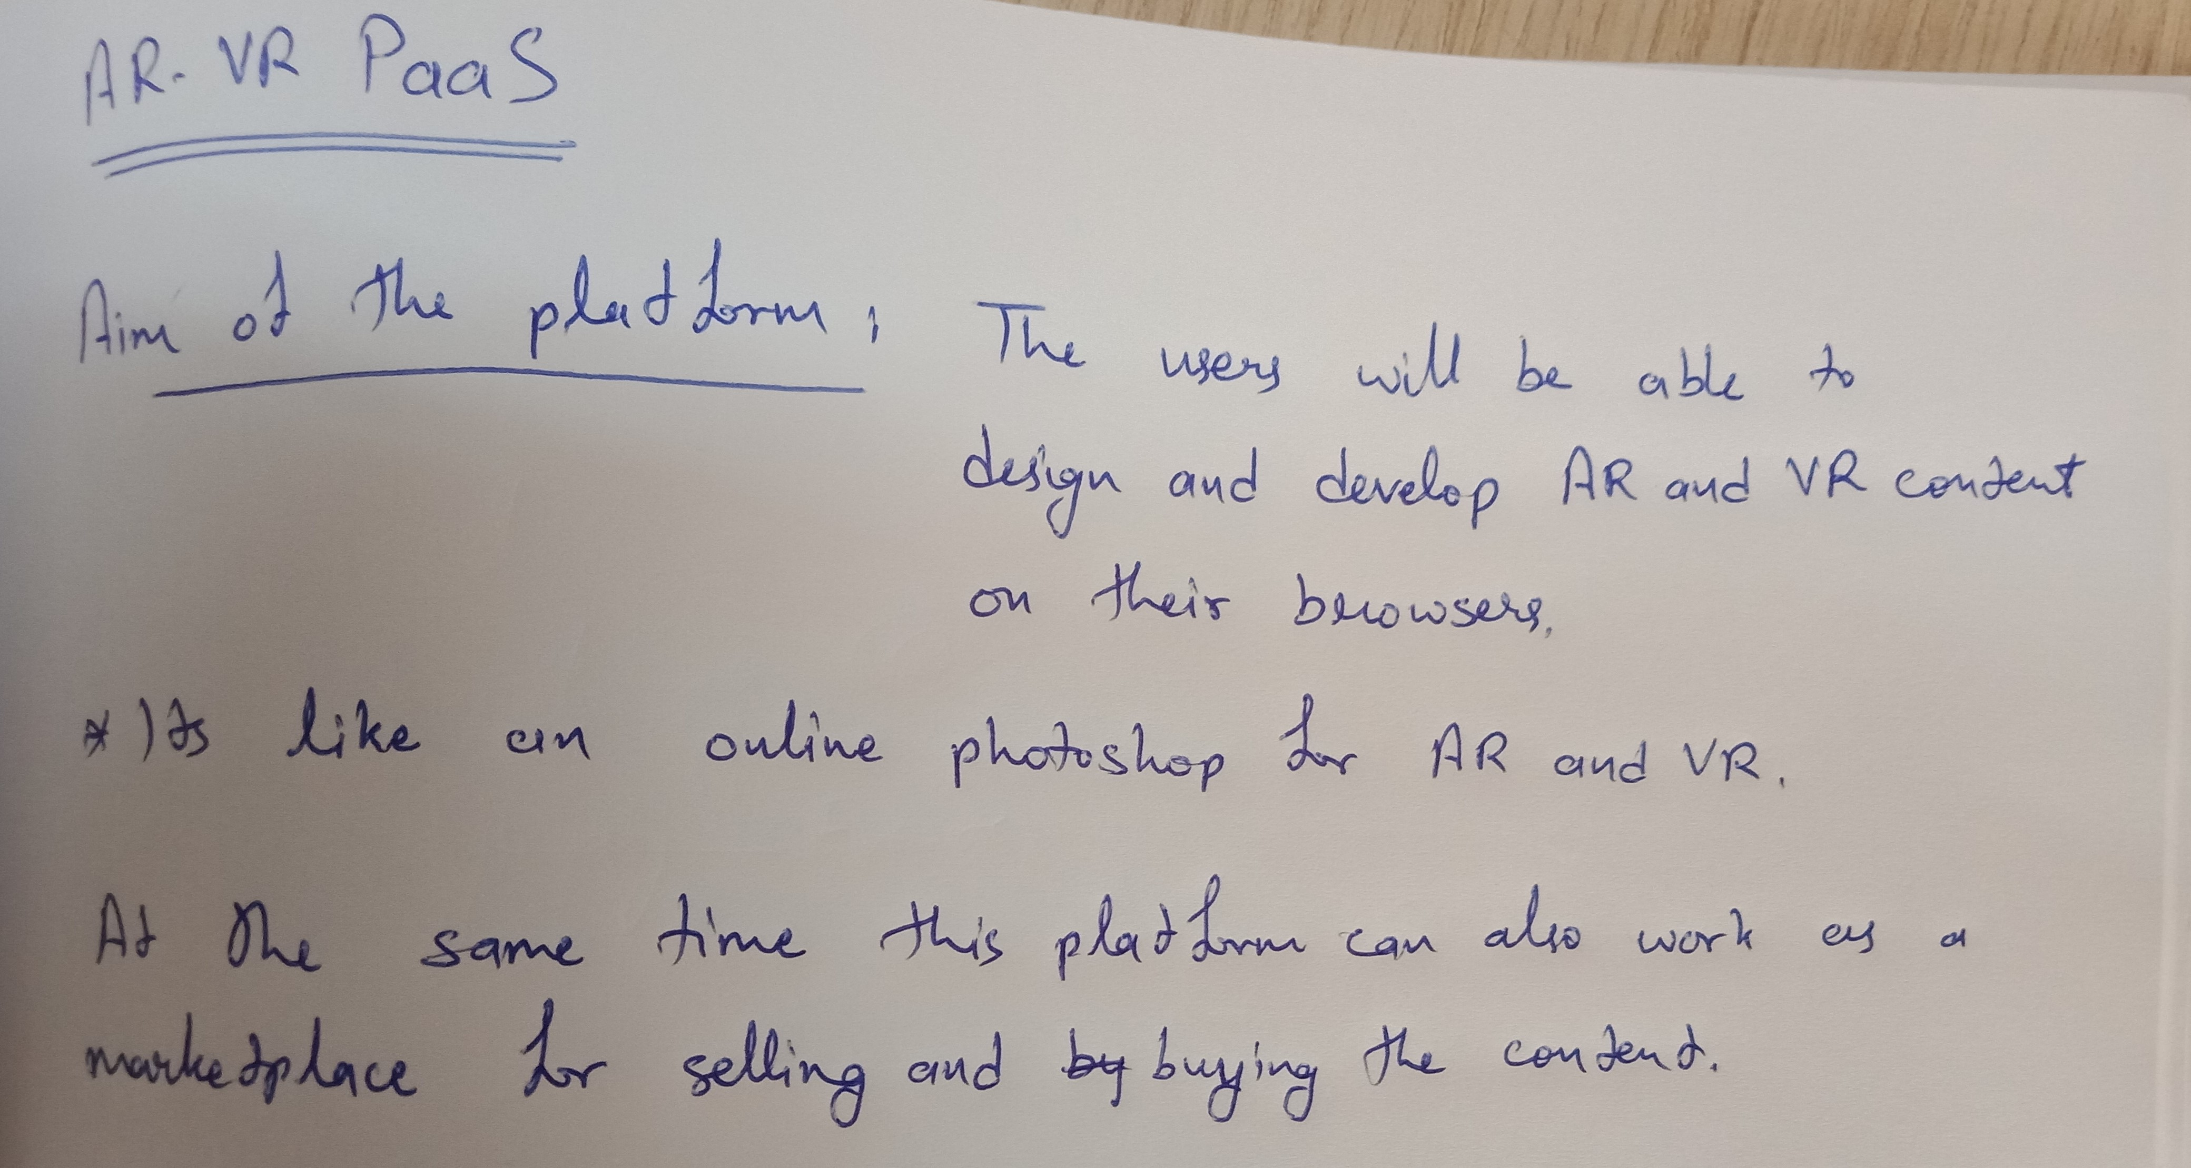

# Requirements (as for now)

* Server Side

1. Cloud Infrastructure (High performance)

2. Internet connectivity (Low latency, high speed fiber optic/5G)

3. Website as a web platform (API also)

* Rapid Application Development methodology of software development

(Server preferences: AWS, Photon Engine)

* User end

1. Computer with basic GPU

2. Internet connectivity (high speed fiber optic/5G with low latency)

3. VR headset (for VR content)

4. Smartphone Application (if used on smartphone)